**Ain Shams University**

**Faculty of Computer & Information Sciences**

**Information Systems Department**

**Real-Estate smart prediction system**

**By:**

Abeer Ahmed Sholkamy [20191700385]

Abdelrahman Mohammed Ahmed [20191700370]

Shehab Adel Abdelgaleel [20191700316]

Osama Ahmed Ahmed [20191700090]

Amany Adel Soliman [20191700131]

Esraa Mohammed Abdelhamid [20191700103]

**Under Supervision of**

[Dr. Sherine Rady],

Information Systems Department,

Faculty of Computer and Information Sciences,

Ain Shams University.

[Dr. Amal Moustafa],

Information Systems Department,

Faculty of Computer and Information Sciences,

Ain Shams University.

**July 2023**

**Acknowledgements**

All praise and thanks to ALLAH, who provided me with the ability to complete this work. I hope to accept this work from me.

I am grateful of *my parents* and *my family* who are always providing help and support throughout the whole years of study. I hope I can give that back to them.

I also offer my sincerest gratitude to my supervisors, *Prof. Dr. Sherine Rady* *and T.A. Amal Moustafa.* who have supported me throughout my thesiswith their patience, knowledge and experience.

Finally, I would like to thank my friends and all people who gave me support and encouragement.

**Abstract**

- A real estate management system is a software application that is designed to automate and streamline the various aspects of real estate transactions, including property listings, lead generation, marketing, contract management, and financial reporting. The system provides real estate professionals with a comprehensive set of tools and data to manage properties efficiently, improve market visibility, and increase transaction volume. The system can be used by various stakeholders in the real estate industry, including brokers, agents, property managers, investors, and buyers and sellers. Overall, a real estate management system aims to improve the efficiency, transparency, and security of real estate transactions, and to provide real estate professionals and clients with new opportunities and insights.

The final results obtained by the developed system: Suitable estate to buy, Suitable buyer to sell or rent your estate, Predicted price of the estate, Best recommendation of the best estate and Better decision-making.

- Firstly, without an intermediary system, users may struggle to access accurate and up-to-date information about properties, market trends, and legal requirements. This can lead to misunderstandings, delays, and mistakes that could result in financial losses and legal disputes.

- Secondly, dealing directly with real estate transactions without an intermediary system can be time-consuming and inefficient. Users may need to spend a significant amount of time searching for properties, contacting sellers or buyers, scheduling appointments, and managing documents.

-Finally, without an intermediary system, users may be exposed to a higher risk of fraud or scams. Intermediary systems often have measures in place to verify the identity and credibility of users and properties, which reduces the risk of fraudulent activities.

**الملخص**

نظام إدارة العقارات هو تطبيق برمجي مصمم لتوفير الأتمتة وتسهيل العمليات المختلفة للمعاملات العقارية، بما في ذلك قوائم العقارات، وتوليد العملاء المحتملين، والتسويق، وإدارة العقود، والتقارير المالية. يوفر النظام مجموعة شاملة من الأدوات والبيانات للمحترفين في مجال العقارات لإدارة العقارات بكفاءة، وتحسين رؤية السوق، وزيادة حجم المعاملات. يمكن استخدام النظام من قبل أصحاب المصلحة المختلفين في صناعة العقارات، بما في ذلك السماسرة، والوكلاء، ومدراء العقارات، والمستثمرين، والمشترين والبائعين. بشكل عام، يهدف نظام إدارة العقارات إلى تحسين كفاءة وشفافية وأمان المعاملات العقارية، وتوفير فرص وإبحار جديدة للمحترفين والعملاء في مجال العقارات.

النتائج النهائية التي يحققها النظام المطور: العقار المناسب للشراء، والمشتري المناسب لبيع أو تأجير العقار، والسعر المتوقع للعقار، وأفضل توصية لأفضل عقار، واتخاذ قرارات أفضل.

أولاً، بدون نظام وسيط، قد يواجه المستخدمون صعوبة في الوصول إلى معلومات دقيقة وحديثة حول العقارات واتجاهات السوق والمتطلبات القانونية. يمكن أن يؤدي ذلك إلى التباسات وتأخيرات وأخطاء يمكن أن تتسبب في خسائر مالية ونزاعات قانونية.

ثانيًا، التعامل مباشرةً في معاملات العقارات بدون نظام وسيط يمكن أن يكون مستهلكًا للوقت وغير فعال. قد يحتاج المستخدمون إلى قضاء الكثير من الوقت في البحث عن العقارات والتواصل مع البائعين أو المشترين وجدولة المواعيد وإدارة المستندات.

وأخيرًا، بدون نظام وسيط، قد يتعرض المستخدمون لمخاطر أعلى من الاحتيال أو الغش. غالبًا ما تكون للأنظمة الوسيطة تدابير للتحقق من هوية المستخدمين ومصداقية العقارات، مما يقلل من مخاطر الأنشطة الاحتيالية.

**Table of Contents**

**Acknowledgements.…….……..……………..………………………………**1

**Abstract………….………………...………………….………………………**2

**List of Figures….……………………………….............…………….………**6

**List of Tables…………...……………………………….……….……….…...**7

**List of Abbreviations….……………………..…………………….…………8**

**Chapter 1: Introduction………………………………………………...……**9

**1.1 Problem Definition…………………………………………**9

**1.2 Motivation…………………………………………………**9

**1.3 Objectives………………………………………………….**9

**1.4 Methodology** **………………………………………………**10

**1.5 Time plan………………………………………………….**10

**1.6 Thesis Outline ……………… ……………………… ……**10

**Chapter 2: Literature Review …………………….…..…………….**12

**Chapter 3: System Architecture and Methods ...………………….16**

**3.1 System Architecture ………………………………………16**

**3.2 Description of methods and procedures used …………18**

**Chapter 4: System Implementation and Results …..……………….19**

**4.1 Dataset ….………………..………………..…………19**

**4.2 Description of Software Tools Used ..………………..……19**

**4.3 Step-up Configuration (hardware)…………………………21**

**4.4 Experimental and Results …..…………………..……22**

**Chapter 5: Run the Application....…………………………..…..29**

**Chapter 6: Conclusion and Future Work………….………………44**

**6.1 Conclusion……………………………………………………44**

**6.2 Future Work……………………………………………………44**

**References……………………………………………………………….…….46**

**List of Figures**

**Figure 1.1:** Time Plane…………………………………………10

**Figure 3.1:** System Architecture………………………………16

**Figure 4.1:** Plot history using Xgboost………………………. 23

**Figure 4.2:** Plot history using ANN…………………………. 26

**List of Tables**

**Table 4.1:** Results of using XGboost ……………………………......22 **Table 4.2:** Importance of features using XGboost …………………...24

**Table 4.3:** Results of using ANN …………………………………… 26

**Table 4.4:** Importance of features using ANN ……………………… 26

**List of Abbreviations**

**XGBoost:** extreme Gradient Boosting

**MVC:** Model-View-Controller

**APIs:** Application Programming Interfaces

**IoT:** internet of things

**IDE:** integrated development environment

**Google Colab:** Google Colaboratory

**VR:** Virtual Reality

**AR:** Augmented Reality

**ANN:** Artificial Neural Network

**CNN:** Convolutional Neural Network

**MSE:** Mean Squared Error

**MAE:** Mean Absolute Error

**Chapter One**

**introduction**

* 1. **Problem Definition**

- Firstly, without an intermediary system, users may struggle to access accurate and up-to-date information about properties, market trends, and legal requirements. This can lead to misunderstandings, delays, and mistakes that could result in financial losses and legal disputes.

- Secondly, dealing directly with real estate transactions without an intermediary system can be time-consuming and inefficient. Users may need to spend a significant amount of time searching for properties, contacting sellers or buyers, scheduling appointments, and managing documents.

-Finally, without an intermediary system, users may be exposed to a higher risk of fraud or scams. Intermediary systems often have measures in place to verify the identity and credibility of users and properties, which reduces the risk of fraudulent activities.

* 1. **Motivation**

- Real estate systems are essential because they streamline the buying, selling, renting, and managing of real estate assets. They provide real estate professionals with the tools and data they need to make informed decisions, reduce transaction times, and improve operational efficiency.

- Real estate systems are crucial for the smooth operation of the real estate industry and for the optimal use of real estates.

* 1. **Objectives**
* Offering help in finding the estate you need in fastest time and easiest way.
* Help you to sell your estate.
* Predicting the price of an estate based on the giving features.
* Prediction whether the estate appropriate for investment or not?
  1. **Methodology**

**-**The methodologies related to the project of real estate management system encompasses various fields, including computer science, data analytics, and real estate economics.

-In computer science, the project requires the development of software applications that can efficiently manage real estate data, automate transactions, and provide user-friendly interfaces for real estate professionals and clients. This involves the use of programming languages, software development frameworks, and databases to design, develop, test, and deploy the software.

-In data analytics, the project requires the collection, processing, and analysis of large amounts of real estate data to provide insights into market trends, property performance, and investment opportunities. This involves the use of data mining, machine learning, and statistical analysis techniques to identify patterns and trends in data and to make accurate predictions.

-In real estate economics, the project requires an understanding of the principles of real estate valuation, property management, and investment analysis. This involves knowledge of market dynamics, legal and regulatory frameworks, and financial modeling techniques to make informed decisions about buying, selling, leasing, or managing real estate assets.

* 1. **Time plan**

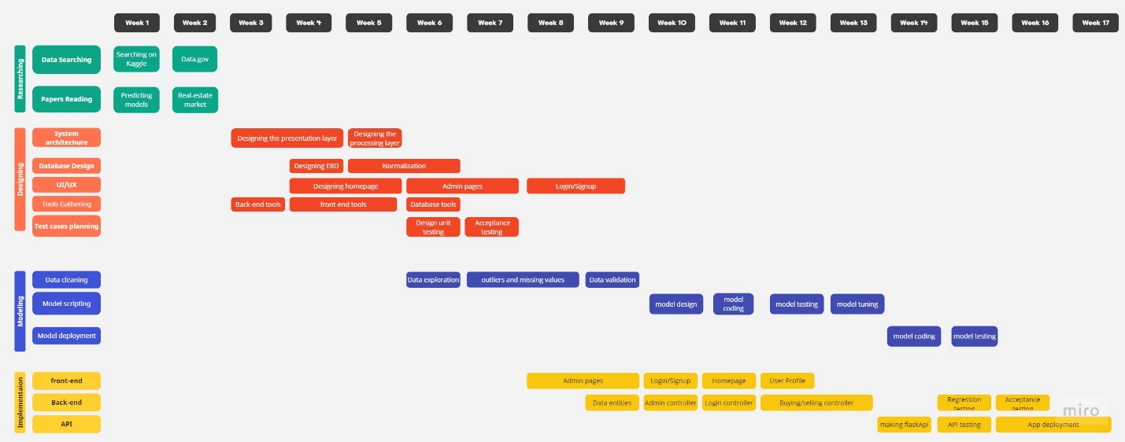

**Figure1.1 Time Plan**

**1.6 Thesis Outline**

**-Chapter 1:** introduction about the project, problem definition and motivation.

**-Chapter 2:** includes Theoretical Background and The previous studies and works.

**-Chapter 3:** includes System Architecture and Methods.

**-Chapter 4:** includes System Implementation and Results.

**-Chapter 5:** includes the run of the website.

**-Chapter 6:** includes Conclusion and Future Work.

**Chapter Two**

* **Introduction**

- The project holds immense importance and significance in today's digital age. With the rapid growth of the internet and technology, the real estate industry is evolving and becoming increasingly interconnected. An online management system revolutionizes the way properties are managed, offering a centralized platform for efficient data management, streamlined operations, and improved communication. By embracing this project, stakeholders in the real estate industry can harness the power of technology to enhance productivity, optimize financial management, provide a seamless tenant experience, and make data-driven decisions. It empowers the industry to adapt to the changing needs of the market and leverage technology as a competitive advantage, ultimately leading to growth, profitability, and success in the dynamic world of real estate.

* **Theoretical Background**

-The field of real estate management system has seen significant developments in recent years, with various research studies and practical applications aimed at improving the efficiency and effectiveness of real estate transactions. Here are some examples of the work done in this field:

-Real estate data analytics: Data analytics techniques such as machine learning and data mining have been applied to real estate data to identify market trends, property performance, and investment opportunities. Researchers have developed predictive models that can accurately forecast property prices and rental rates, allowing real estate professionals to make informed decisions about buying, selling, leasing, or managing properties.

-Blockchain-based real estate systems: Blockchain technology has been applied to real estate transactions to improve transparency, security, and efficiency. Researchers have developed blockchain-based systems that can automate the process of transferring property ownership, reduce transaction costs, and prevent fraud.

-Smart building technology: Smart building technology such as Internet of Things (IoT) devices, sensors, and automation systems have been used to improve the management and maintenance of real estate assets. Researchers have developed systems that can monitor energy consumption, detect maintenance issues, and optimize building operations, resulting in cost savings and improved sustainability.

-Real estate management software: Real estate management software has been developed to provide real estate professionals with the tools and data they need to manage properties efficiently. These software systems include features such as lease management, rent collection, maintenance tracking, and financial reporting.

-Online real estate marketplaces: Online real estate marketplaces such as Zillow and Redfin have transformed the way real estate transactions are conducted, providing buyers and sellers with easy access to property information, pricing data, and transaction services.

* **Scientific Background**

- The scientific background related to the project of real estate management system encompasses various fields, including computer science, data analytics, and Machine Learning.

-In computer science, the project requires the development of software applications that can efficiently manage real estate data, automate transactions, and provide user-friendly interfaces for real estate professionals and clients. This involves the use of programming languages, software development frameworks, and databases to design, develop, test, and deploy the software.

-In data analytics, the project requires the collection, processing, and analysis of large amounts of real estate data to provide insights into market trends, property performance, and investment opportunities. This involves the use of data mining, machine learning, and statistical analysis techniques to identify patterns and trends in data and to make accurate predictions.

-Machine Learning: Machine learning is a subset of AI that enables computers to learn patterns and make predictions or decisions without being explicitly programmed. Real estate prediction systems use machine learning algorithms to train models on historical data and then make predictions based on new data inputs. Using XGBoost algorithm to predict the price of an estate, and using sentiment analysis to evaluate the rate of the user based on reviews.

* **The previous studies and works**

- There are several existing similar systems to real estate management systems, each with their unique features and functionalities. Here are a few examples:

Propertybase: Propertybase is a real estate CRM and marketing platform that provides a comprehensive set of tools for managing real estate transactions. The platform includes features such as lead capture, property search, transaction management, and marketing automation.

Yardi: Yardi is a property management software that helps real estate professionals manage residential and commercial properties. The software includes features such as rent collection, maintenance tracking, tenant screening, and financial reporting.

CoStar: CoStar is a real estate information and analytics platform that provides access to a comprehensive database of commercial properties, sales and lease transactions, and market trends. The platform includes features such as property search, market analysis, and data visualization tools.

Buildout: Buildout is a marketing and deal management platform for commercial real estate professionals. The platform includes features such as property marketing, document management, and deal tracking.

RealPage: RealPage is a property management software that helps real estate professionals manage multifamily, single-family, and commercial properties. The software includes features such as leasing, maintenance, financial management, and marketing automation.

* **Functional Requirements**

User:

* Login & Register
* Sell an estate
* Buy an estate
* Edit profile
* Rent an estate
* Put an estate for rent

System:

* Predict the price
* Recommend estates
* **Nonfunctional Requirements**
* **Performance:** The system is able to handle a large volume of transactions and provide fast response times to ensure user satisfaction.
* **Security:** The system has robust security measures in place to protect user data and prevent unauthorized access or data breaches.
* **Reliability:** The system is highly available and dependable, with minimal downtime or disruptions to ensure user satisfaction and trust.
* **Scalability:** The system is able to accommodate growth in the number of users and properties without compromising performance or quality.
* **Usability:** The system is easy to use and navigate, with an intuitive user interface and clear documentation to ensure user satisfaction and adoption.
* **Compatibility:** The system is compatible with various operating systems, browsers, and devices to ensure user accessibility and flexibility.
* **Maintainability:** The system is easy to maintain and update, with clear documentation and modular design to ensure cost-effectiveness and longevity.
* **Compliance:** The system complies with legal and regulatory requirements, such as data privacy and protection laws, to ensure user trust and adherence to industry standards.

**Chapter Three**

**3.1 System Architecture**

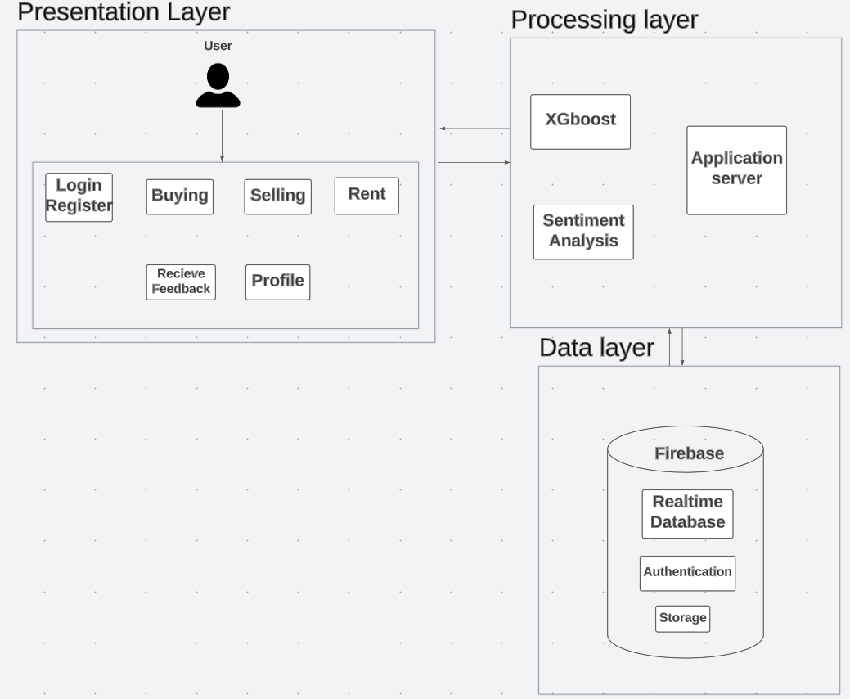

**Figure3.1 System Architecture**

1. **Presentation Layer**

-It serves as the user interface or the front-end of the system, facilitating communication and interaction between users and the underlying system.

-The main purpose of the presentation layer is to present data and information to users in a human-readable and meaningful format. It handles the transformation, formatting, and rendering of data received from the underlying layers, making it easily understandable and accessible to users. This layer is responsible for ensuring that the user interface is intuitive, visually appealing, and responsive.

-Each user can login and register, can buy or sell estates, can either rent or offer his estate for rent, can edit his profile, can receive feedback.

1. **Processing Layer**

-the processing layer, also known as the business logic layer or application layer, is responsible for the core processing and functionality of the system. It serves as the intermediary between the presentation layer (user interface) and the data layer (data storage and retrieval).

-The processing layer encapsulates the business rules, algorithms, computations, and decision-making logic that define how the system operates and processes data. It ensures that the system functions correctly, performs necessary operations, and enforces the business requirements.

-Using XGboost to predict the price and using sentiment analysis to evaluate the rate of the user based on reviews.

1. **Data Layer**

-the data layer, also known as the data tier or data access layer, is responsible for managing the storage, retrieval, and manipulation of data within the system. It serves as the underlying infrastructure that handles data persistence and provides access to data for other layers of the system.

-The data layer interacts directly with data sources, such as databases, file systems, or external data services, and abstracts the complexities of data storage and retrieval from the other layers.

-Using Firebase: Real-time database, Authentication and Cloud storage.

**3.2 Description of methods and procedures used**

**- XGBoost:**

* To predict the price of an estate
* XGBoost is a popular algorithm for solving supervised learning problems, such as regression and classification.
* XGBoost is a popular algorithm for solving supervised learning problems, such as regression and classification.
* XGBoost is a powerful machine learning algorithm that has gained significant popularity and success in various data science and machine learning competitions. It is an implementation of the gradient boosting framework, which combines multiple weak predictive models (typically decision trees) to create a strong predictive model.

**-Sentiment analysis:**

-Sentiment analysis, also known as opinion mining, is the process of determining and analyzing the emotional tone or sentiment expressed in a piece of text, such as reviews, social media posts, customer feedback, and more. It holds significant importance in various domains and applications.

-using sentiment analysis to evaluate the rate of the user based on reviews.

**Chapter Four**

**System Implementation and Results**

**4.1 Dataset**

-Egypt villas price depending on amenities and city locations 2022.

- a collection of data that provides information about the prices of villas in Egypt. It focuses on the relationship between villa prices and factors: Type, Bedrooms, Bathrooms, Area, Furnished, Compound, Payment_Option, Delivery_Date, Delivery_Term, City, Description, Private_Garden, Security, Balcony, Pets_Allowed, covered_Parking, Maids_Room, Electricity_Meter, Natural_Gas, Landline, Pool, Central_heating, Built_in_Kitchen_Appliances, Elevator.

-Analyzing this dataset could involve exploring the relationships between villa prices, different amenities, and city locations. It could help identify which amenities or locations have a significant impact on villa prices and provide insights into the factors influencing the real estate market in Egypt in 2022.

-the dataset includes 8908 rows and 25 columns

* 1. **Description of Software Tools Used**

**-Firebase:**

* Firebase is a comprehensive platform provided by Google that offers a wide range of tools and services for building and managing web and mobile applications. It provides developers with a serverless backend infrastructure, allowing them to focus on app development without the need to manage servers or infrastructure setup.
* Firebase simplifies the development process by offering a suite of tools and services to handle backend infrastructure, data storage, authentication, notifications, and analytics. It enables developers to build high-quality applications faster and focus on delivering great user experiences.
* **Real-time Database:** Firebase offers a NoSQL cloud-hosted database that allows developers to store and synchronize data in real-time across multiple clients. It uses a JSON-like data structure and provides real-time data synchronization, enabling applications to instantly reflect changes made by any connected client.
* **Authentication:** Firebase provides a user authentication system that simplifies user management and authentication processes. It supports authentication using popular methods such as email/password, social media logins (e.g., Google, Facebook, Twitter), and more. This feature allows developers to easily secure their applications and manage user accounts.
* **Cloud Storage:** Firebase allows developers to store and serve user-generated content such as images, videos, and other files using Cloud Storage. It provides a scalable and secure solution for storing and retrieving files, with options for fine-grained access control and integration with Firebase authentication.

**-MVC:**

* MVC stands for Model-View-Controller, which is a software architectural pattern widely used in the development of web and desktop applications. It separates an application into three main components: The Model, the View, and the Controller. Each component has a specific responsibility, which helps in organizing and managing the codebase effectively.
* The MVC pattern promotes separation of concerns and modularization of code, making it easier to maintain and extend applications. It allows for code reusability and facilitates collaboration among developers working on different parts of the application. Additionally, the separation of the user interface (View) from the business logic (Model) enhances code readability, testability, and flexibility.

**-Visual Studio:**

* Visual studio is used to implement MVC
* Visual Studio is an integrated development environment (IDE) created by Microsoft that provides a comprehensive set of tools and features for software development. It is widely used by developers for building a variety of applications, including desktop, web, mobile, cloud, and gaming applications.

**-PyCharm:**

* To implement models
* PyCharm is an integrated development environment (IDE) specifically designed for Python development. It is developed by JetBrains, a software development company known for creating powerful IDEs for various programming languages. PyCharm provides a comprehensive set of tools and features that enable developers to write, debug, test, and deploy Python applications efficiently

**-Google colab:**

* Google colab is a cloud-based platform provided by Google that allows users to write, execute, and share Python code in a web browser. It offers a Jupyter Notebook environment with integrated support for running Python code, visualizing data, and performing various machine learning tasks.

**-Flask API:**

* Flask is a popular Python web framework that enables developers to build web applications and APIs quickly and easily. With Flask, you can create RESTful APIs (Application Programming Interfaces) to expose your application's functionality and data to other systems or clients.

**-Bootstrap:**

* Bootstrap is a popular front-end framework that provides a collection of CSS and JavaScript components, styles, and utilities to build responsive and visually appealing web pages and applications. It simplifies web development by offering pre-designed and customizable elements that can be easily integrated into the project.
  1. **Step-up Configuration (hardware)**
* CPU: Intel Celeron G5900, 2 cores, 2 threads, base clock speed of 3.4 GHz, boost clock speed of 3.9 GHz
* RAM: 4 GB DDR4-2400
* Storage: 128 GB SATA III solid-state drive
* Graphics card: Integrated Intel UHD Graphics 630
* Motherboard: Micro ATX motherboard with Intel B660 chipset
* Power supply: 450-watt power supply
* Cooling system: Stock cooler

**4.4 Experimental and Results**

**-Using XGboost to predict the price**

-results:

|  |  |
| --- | --- |
|  | XGboost |
| **Mean absolute error** | 1926584.31 |
| **Mean squared error** | 7823557174860.56 |
| **Median absolute error** | 1337249.75 |
| **Explain variance score** | 0.69 |
| **R2 score** | 0.69 |

**Table4.1 Results of XGboost**

-measure the performance by using Mean Squared Error and Mean Absolute Error

**MSE** = (1/n) * Σ (yᵢ - ȳ) ²

where:

* MSE represents the Mean Squared Error.
* n is the total number of data points or observations.
* yᵢ represents the actual value of the i-th observation or data point.
* ȳ represents the predicted value of the i-th observation or data point.
* Σ denotes the summation symbol, indicating that you need to sum up the squared differences across all data points or observations.

**MAE** = (1/n) * Σ|yᵢ - ȳ|

where:

* MAE represents the Mean Absolute Error.
* n is the total number of data points or observations.
* yᵢ represents the actual value of the i-th observation or data point.
* ȳ represents the predicted value of the i-th observation or data point.
* | | denotes the absolute value function, which ensures that the differences between the actual and predicted values are positive.

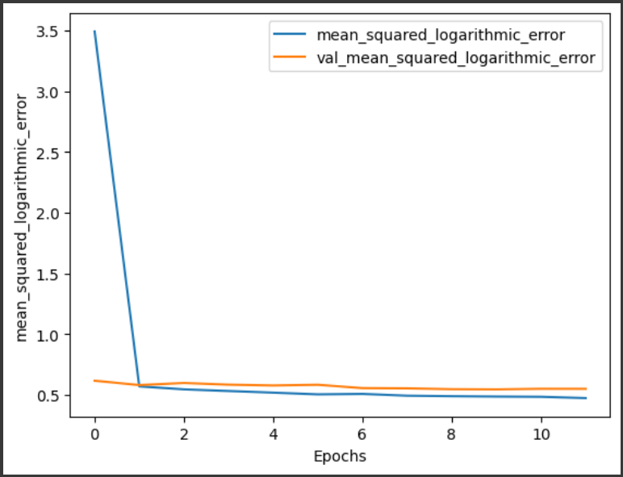

**Figure4.1 Plot history of XGboost**

-using Mutual Information Regression to measure the statistical dependence between two variables, the mutual information between the predictor variable(s) and the target variable is estimated.

**I(X;Y)** = ∑ ∑ p(x,y) log(p(x,y) / (p(x) * p(y)))

where:

* p(x, y) is the joint probability distribution of X and Y (estimated from the data)
* p(x) is the marginal probability distribution of X (estimated from the data)
* p(y) is the marginal probability distribution of Y (estimated from the data)
* The summation is performed over all unique values of X and Y in the dataset.

-importance of features:

|  |  |
| --- | --- |
| Area | 0.863977 |
| Payment_Option | 0.228052 |
| Bathrooms | 0.121363 |
| Bedrooms | 0.083963 |
| Pool | 0.050154 |
| Elevator | 0.030619 |
| Pets_Allowed | 0.029793 |

**Table4.2 Importance of features using Xgboost**

-results in the system:

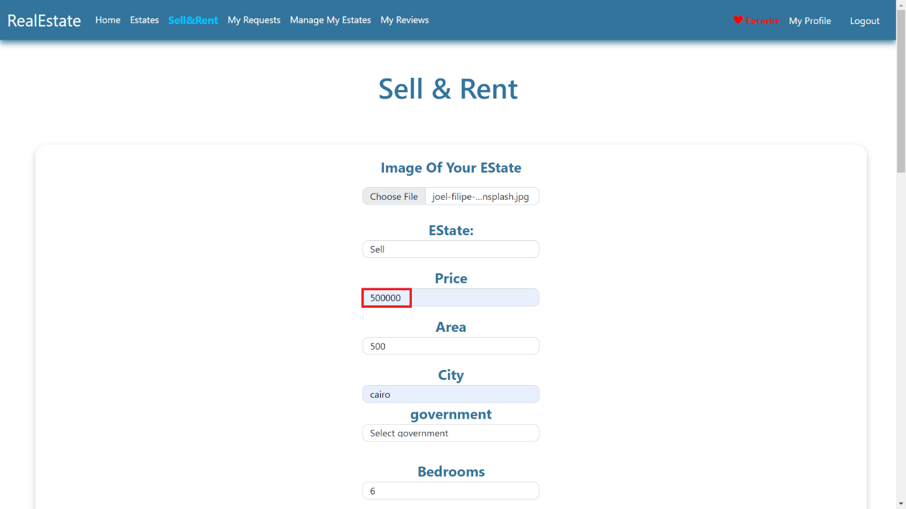

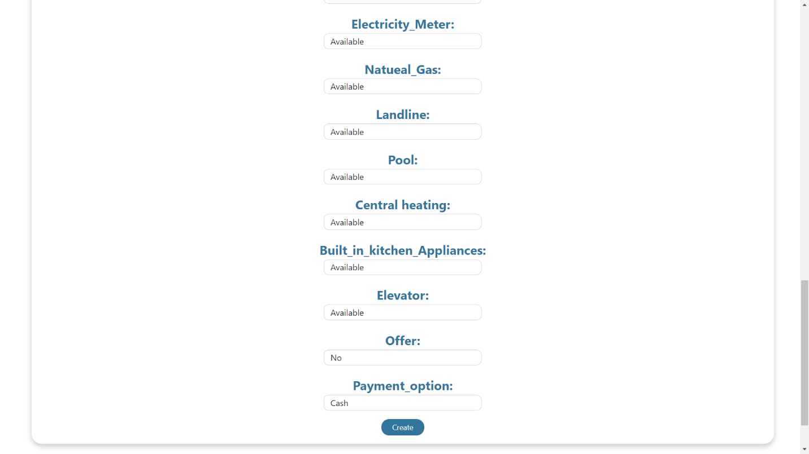

-Enter the estate’s features and wait to show the predicted price.

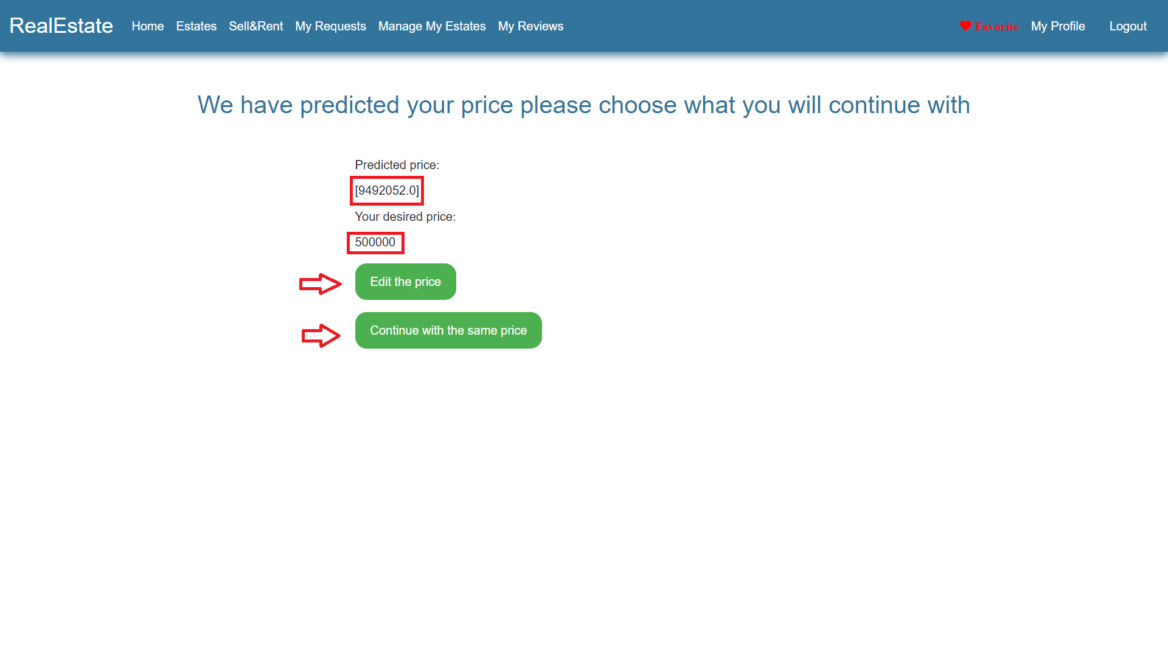

**-Using ANN to predict the price**

-results:

|  |  |
| --- | --- |
|  | ANN |
| **Mean absolute error** | 709162.66 |
| **Mean squared error** | 1334609082788.72 |
| **Median absolute error** | 428703.5 |
| **Explain variance score** | 0.56 |
| **R2 score** | 0.56 |

**Table4.3 results of ANN**

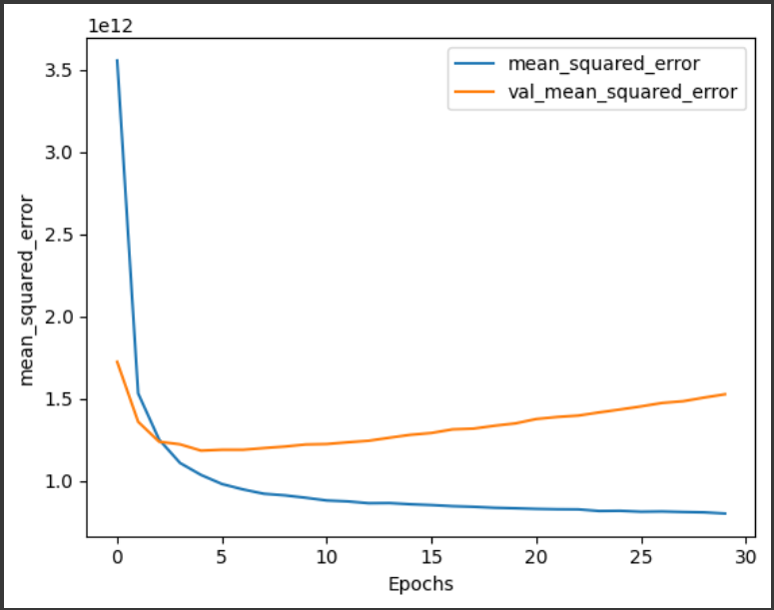

**Figure4.2 Plot history of ANN**

-importance of features:

|  |  |
| --- | --- |
| Area | 0.491899 |
| Bathrooms | 0.190262 |
| Payment_Option | 0.131922 |
| Bedrooms | 0.111004 |
| Delivery_Date | 0.095696 |
| Delivery_Term | 0.090273 |
| Type | 0.086459 |

**Table4.4 Importance of features using ANN**

-Reasons for using XGboost:

* Performance and speed: XGBoost is known for its efficiency and speed in training and making predictions. It utilizes parallel processing and optimized algorithms, making it faster compared to ANNs, especially for large datasets. This can be beneficial when dealing with a substantial amount of real estate data.
* Handling diverse data types: XGBoost can handle a variety of data types, including numerical, categorical, and binary features, without requiring explicit feature engineering. In contrast, ANNs often require extensive preprocessing and normalization for different data types, which can be time-consuming.
* Interpretability: XGBoost provides interpretability in terms of feature importance. It can provide insights into which features are most influential in predicting real estate prices. This can be valuable for understanding the driving factors behind the predictions, especially in real estate where certain features such as location, square footage, or number of bedrooms can significantly impact the price.
* Dealing with missing data: Real estate datasets often contain missing values, and XGBoost can handle missing data without requiring imputation. It automatically learns how to handle missing values during the training process. ANNs, on the other hand, typically require preprocessing steps like imputing missing values, which can introduce additional complexity and potential biases.
* Robustness against outliers: XGBoost has built-in mechanisms to handle outliers and noisy data. It uses decision trees as base learners, which are less sensitive to outliers compared to ANNs. This can be advantageous in real estate, as outliers in the data, such as unusually high or low-priced properties, may have a significant impact on the prediction.
* Avoiding overfitting: XGBoost has regularization techniques, such as L1 and L2 regularization, which help prevent overfitting. Overfitting occurs when a model becomes too complex and starts memorizing the training data instead of learning general patterns. ANNs, especially deep neural networks, are more prone to overfitting, and extensive regularization techniques are often required to mitigate this issue.

**Chapter Five**

**Run the Application**

* **Register:** First, the user must be register on the website.

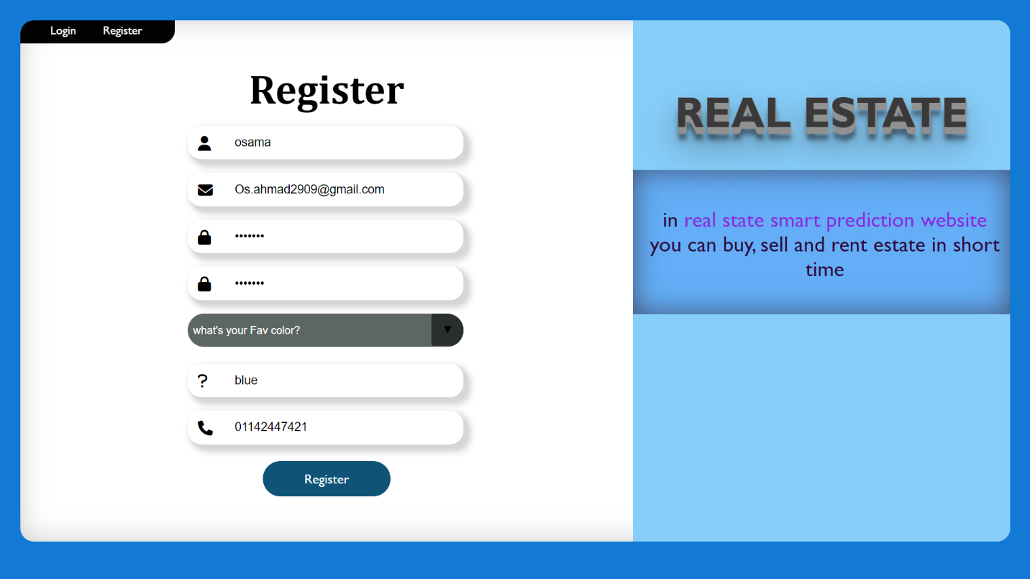

* Should verify email to login.

* **Login**
* if not remember password can reset password

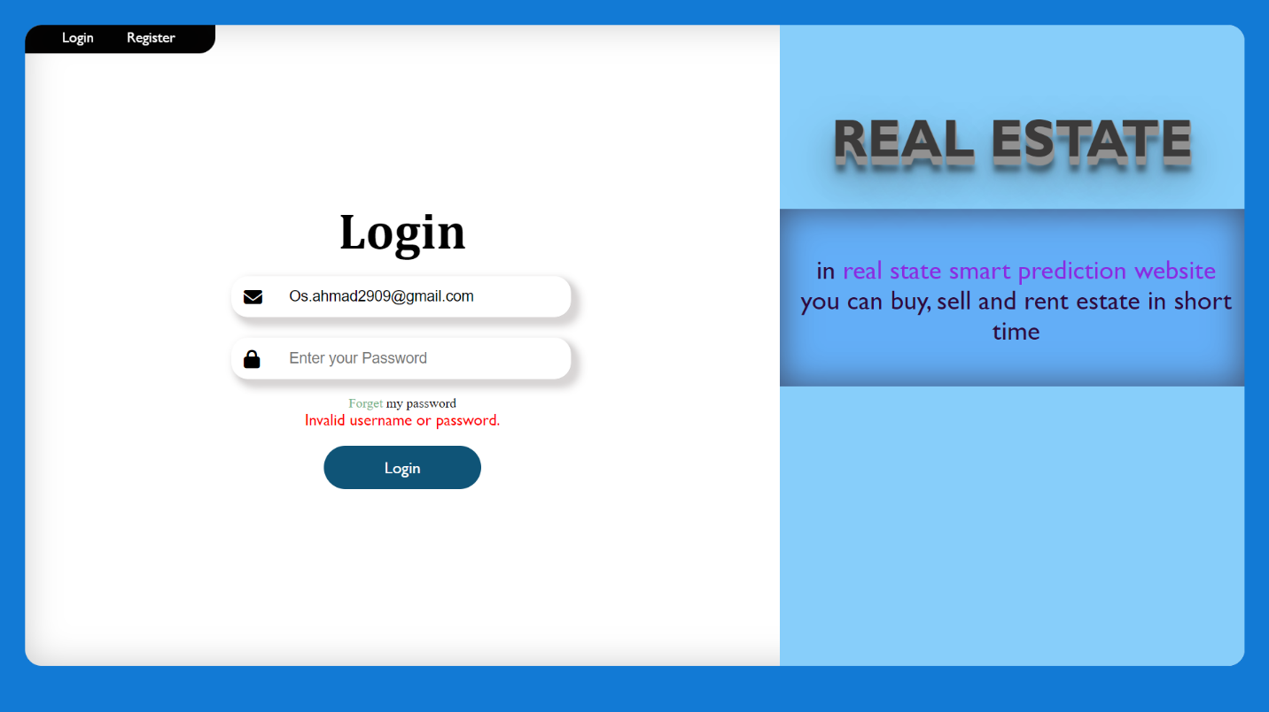

* **Forget** **Password**
* Answer the question in the first.

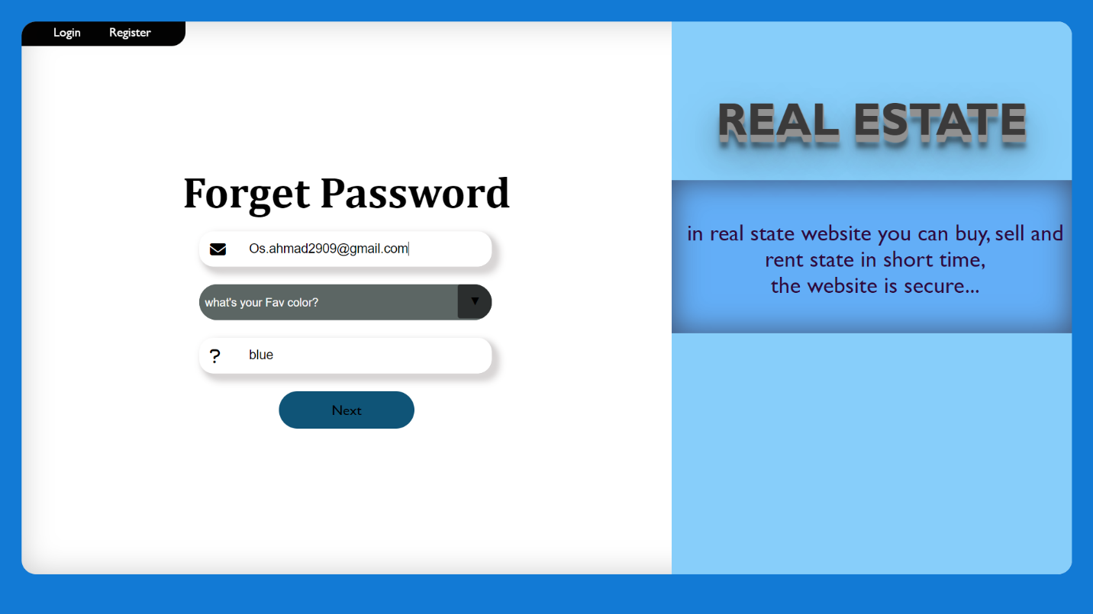

* Then change the password.

* Choose Your Interested in the first time in login.

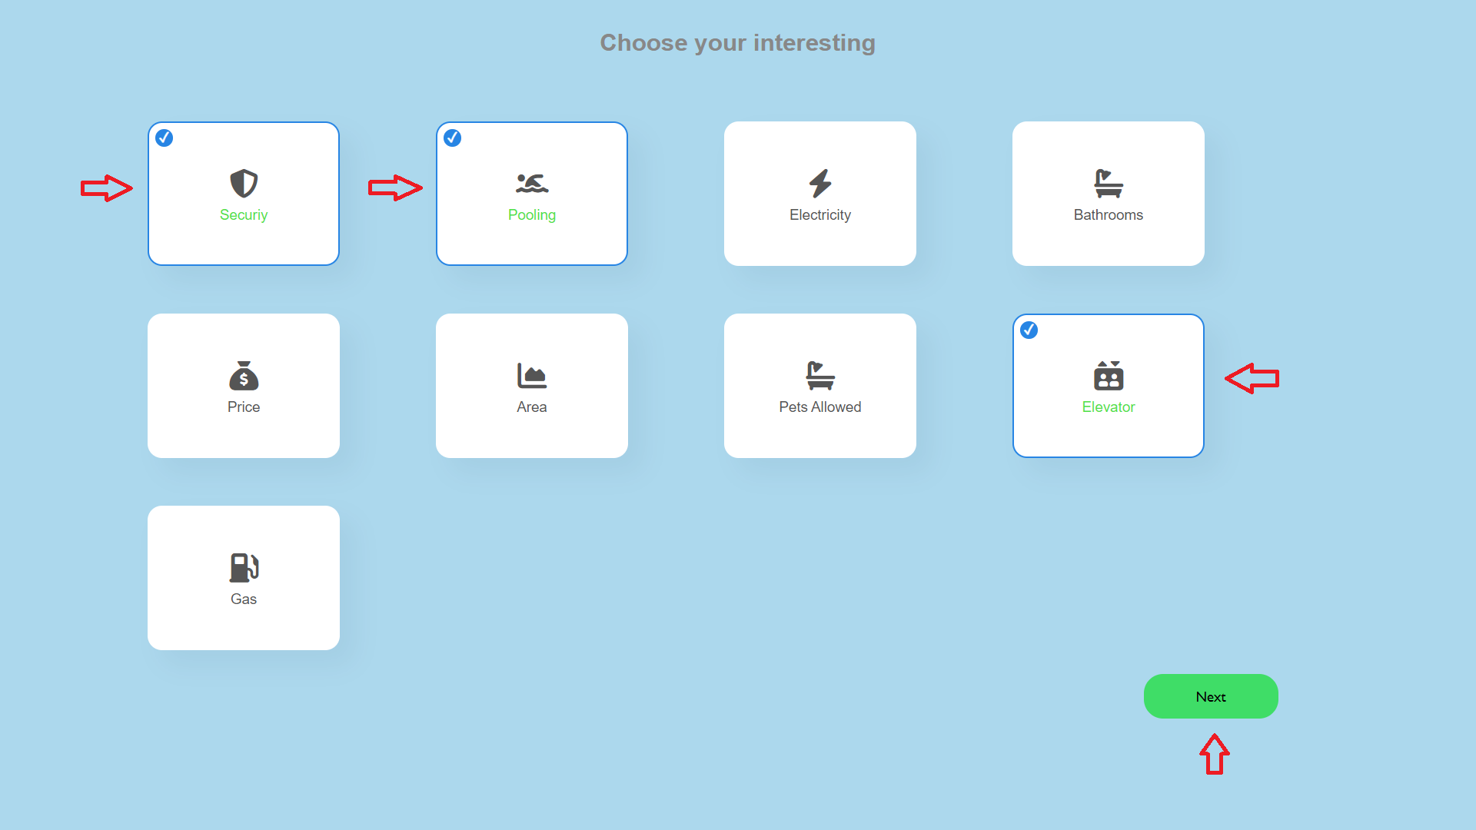

* **My profile:** contains user profile details, you can edit your account or change your image.

* Edit your account (Add Bio).

* After Edit Bio

* **Sell&Rent**: contains of some input fields that user should enter to sell or rent your estate

* The system predicts a suitable price if you want to change the actual price.

* **Estates:** contains the estates you may want to buy them. Users can search by price, city, and Area and filter, user can edit their own estate, or delete it.
* User can view details of the estate or add it to your favorite.

**-** filter by offers

**-** Search by price

* Result

* **Favorite**

* **Buy & Rent:** should view details in the first.

- after click buy send email and request add to my requests.

* **My Requests:** show your requests and can delete them.

* **Manage My Estate:** the seller sees requests on his Estates and verify who sell, then can buyer review the seller from My reviews.

* Show profile and rate.



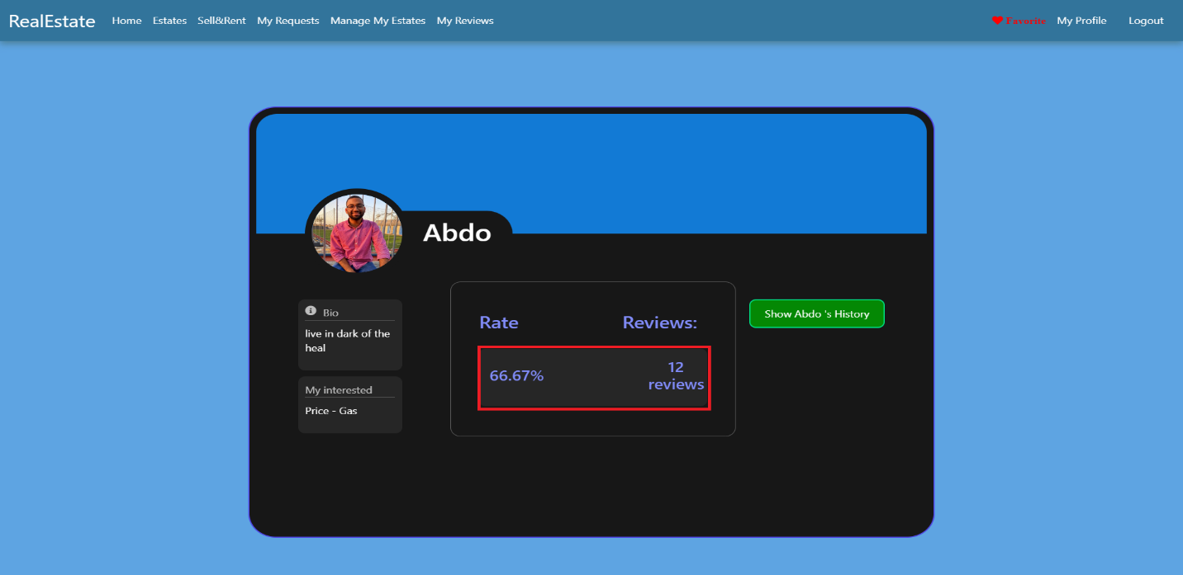

* **My Reviews**

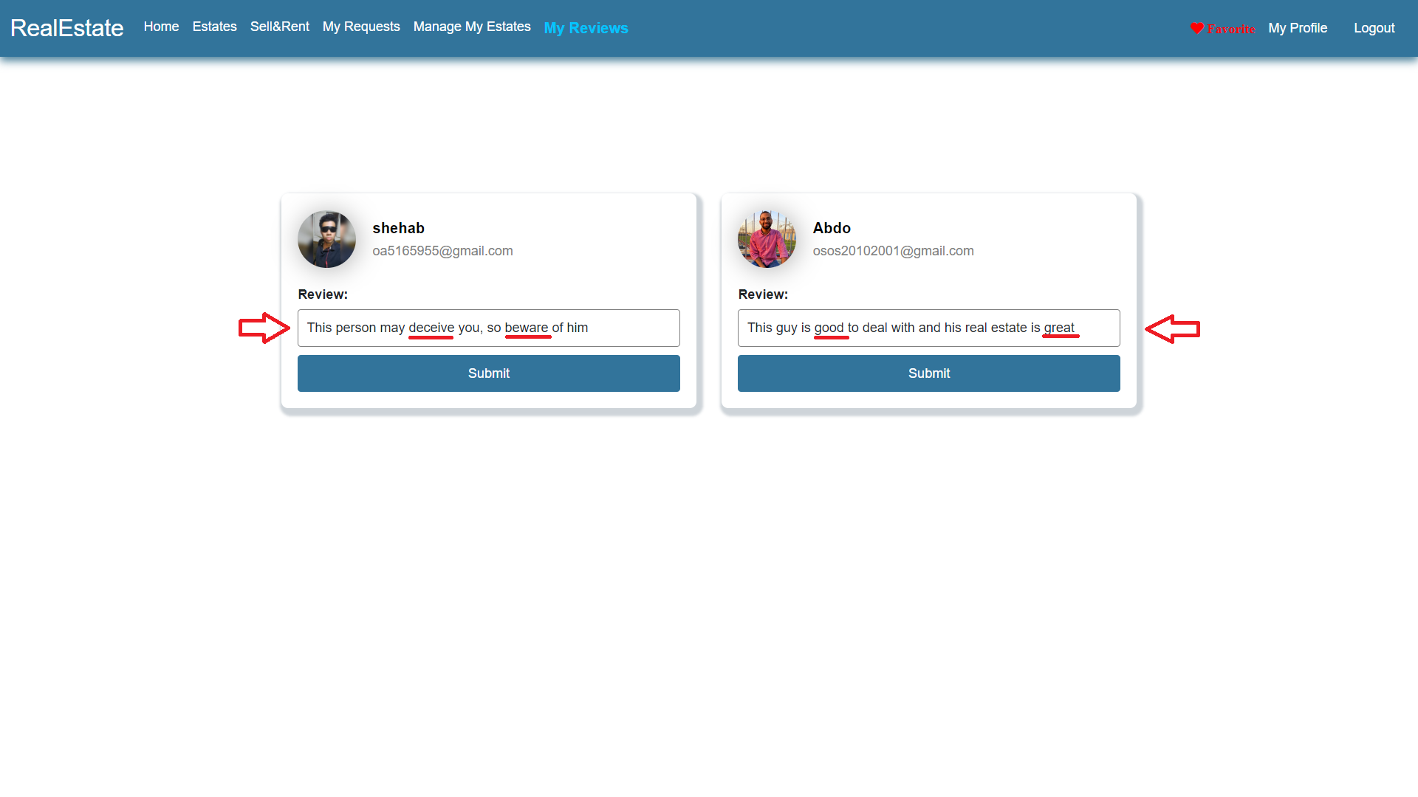

* **After Review**
* Negative review decreases his rate.

* From show history can view His reviews.

* Positive review Increase his rate.



* Show History

* **Home:** contains best sellers and contact us





* Admin can see All Messages of Contact Us.

**Chapter Six**

**Conclusion and Future Work**

**6.1 Conclusion**

* After completing the project with all the models achieving their goals, the main outcome resolved was that the area of a property is the most important factor in determining the price of the property.
* The importance of this system comes from the market analysis, determining the pricing strategies and saving time for customers to find the appropriate property for them to buy or rent or even sell.

**6.2 Future Work**

* One of the drawbacks of this system is lack of the large datasets, large datasets help in making the predicting model more accurate and achieving that would help in making the customer experience better, this can be achieved by pipelining the stated that were sold/bought through the system to the dataset to increase model performance
* There can be in the future a mechanism to check the image of the proposed property to be a real property and not a scam using image recognition technologies and CNN models.
* Virtual Reality (VR) and Augmented Reality (AR): Integrating VR and AR technologies into the system can allow users to virtually explore properties, visualize renovations, and experience different design options. This immersive experience would enhance property viewing, especially for remote buyers or investors.
* Blockchain Integration: Implementing blockchain technology can bring transparency, security, and efficiency to real estate transactions. The system can leverage smart contracts to automate contract execution, securely store property records, and facilitate decentralized property ownership verification.
* Social Collaboration: The system can incorporate social collaboration features, allowing real estate professionals, investors, and buyers to connect, share insights, and collaborate on deals. This fosters a sense of community and provides a platform for knowledge exchange within the real estate industry.

REFERENCES

[1] Varma, A., Sarma, A., Doshi, S. et al.: House Price Prediction Using Machine Learning and Neural Networks. 2018 Second International Conference on Inventive Communication and Computational Technologies (ICICCT), 1936-1939 (2018).

[2] Henry, C., Paul, D., Theo, D., Stephen A. J.: A spatio-temporal, Gaussian process regression, real-estate price predictor. In Proceedings of the 24th ACM SIGSPATIAL International Conference on Advances in Geographic Information Systems (SIGSPACIAL '16). Association for Computing Machinery, New York, NY, USA, Article 68, 1–4 (2016).

[3] Aswin Sivam Ravikumar, School of Computing , National College of Ireland, Real Estate Price Prediction Using Machine Learning , December 2017.

[4] X. Ren, H. Guo, S. Li and S. Wang and J. Li, "A Novel Image Classification Method with CNN-XGBoost Model", International Publishing in Digital Forensics and Watermarking, pp. 378-390, 2017.

[5] T. Chen and C. Guestrin, "XGBoost: “A Scalable Tree Boosting System”", Proceedings of the 22nd acm sigkdd international conference on knowledge discovery and data mining, pp. 785-794, 2016.

[6] Leo Breiman, Statistics Department, University of California, Berkeley,CA 94720, ” RANDOM FORESTS ”, January 2001.

[7] Dey, S. K., Urolagin, S.: Real Estate Price Prediction using Data Mining Techniques. 2021 IEEE 4th International Conference on Computing, Power and Communication Technologies (GUCON), 1-4 (2021).

[8] S.C. Dharmadhikari, Veerraju Gampala, Ch. Mallikarjuna Rao et al., "A smart grid incorporated with ML and loT for a secure management system", Microprocessors and Microsystems, vol. 83, 2021.

[9] Debanjan Banerjee, Suchibrota Dutta, “Predicting the Housing Price Direction using Machine Learning Techniques”, IEEE International Conference on Power, Control, Signals and Instrumentation Engineering (ICPCSI),2017.

[10] Maclennan, D.: Some Thoughts on the Nature and Purpose of House Price Studies. Urban Studies, 14(1), 59–71 (1977).